**STOCK PRICE PREDICTION USING**

**AI & DS**

**STOCK PRICE PREDICTION:-**



The stock market is a complex and dynamic system that is influenced by numerous factors, making it difficult to predict with certainty. However, the emergence of artificial intelligence (AI) has revolutionised the way we analyse and forecast stock market movements. AI algorithms and techniques have proven to be effective in improving prediction accuracy and providing valuable insights to investors. In this article, we will explore how AI contributes to predicting the stock market, the specific techniques used, the benefits it brings, and the limitations and challenges associated with its use.

PROBLEM DEFINITION

The problem is to create an accurate and robust predictive model for forecasting stock prices based on historical market data . The objective of stock price prediction is to create a predictive model that can forecast the future prices of individual stocks or the overall performance of financial markets. This task involves analysing historical market data and utilizing various techniques to make accurate predictions about the future behaviour of stock prices. The primary goals are to assist investors, traders, and financial analysts in making informed decisions, optimizing investment strategies, and managing risk effectively. Key components of this problem include data collection, data preprocessing, feature selection or engineering, model development, training, and evaluation. Successful stock price prediction can have significant implications for financial decision-making and portfolio management.

DESIGN THINKING

* Data Collection for Stock Price Prediction:

The first step in building a stock price prediction model is to collect historical stock market data. This dataset should include a range of features and information to be used in the prediction process. Here's what to collect:

1**. Date**: Gather daily or time-specific data points, including the date of each observation. This helps establish a chronological order for the data.

2. **Open Price**: Record the opening price of the stock on each trading day. This is the price at which the stock first trades when the market opens.

3. **Close Price**: Capture the closing price of the stock for each trading day. This is the price at which the stock ends trading for the day.

4. **Volume**: Collect the trading volume, which represents the total number of shares traded on a particular day. This can be a valuable indicator of market sentiment.

5. **High and Low Prices**: Include the highest and lowest prices at which the stock traded during the day. These provide insights into intraday price fluctuations.

6. **Additional Indicators**: Depending on your model's complexity, you may want to gather other indicators such as moving averages, volatility measures (e.g., standard deviation), technical indicators (e.g., RSI, MACD), and macroeconomic data (e.g., interest rates, GDP growth) that could impact stock prices

7**. Company-specific Data**: If relevant, include company-specific data like earnings reports, news sentiment scores, and other information that could affect the stock's performance.

8. **Market Index Data**: Consider incorporating data from broader market indices (e.g., S&P 500) as they can provide context and impact individual stock prices.

9. **Dividend and Split Information**: Include any data related to stock splits or dividend payments, as these events can significantly influence stock prices.

10**. Source and Quality**: Ensure the data is sourced from reliable sources and is of high quality. Data accuracy and completeness are critical for model performance.

**Data Collection and Preprocessing:** This phase involves gathering historical stock data, which includes price, volume, and other relevant financial indicators. This data often comes in the form of time series data. Preprocessing includes handling missing values, normalizing data, and possibly feature engineering.

**Feature Selection and Engineering:** Identifying and creating relevant features that can help in better predictions. Features could include technical indicators (e.g., moving averages, RSI), fundamental indicators (e.g., earnings per share, P/E ratio), or sentiment analysis from news or social media data. Feature selection is also essential to reduce noise and improve the model's efficiency.

**Model Selection:** Choosing an appropriate model or combination of models for prediction. Common models used in stock price prediction include linear regression, ARIMA, GARCH, decision trees, random forests, support vector machines, neural networks (like LSTM, GRU), and more recently, deep learning models. The choice of model depends on the data, the problem, and the trade-offs between accuracy and interpretability.

**Training and Validation:** Splitting the data into training, validation, and test sets. The model is trained on historical data, and hyperparameters are tuned using the validation set to optimize performance. Cross-validation or time-series specific validation techniques (like rolling window validation) are often used due to the temporal nature of stock market data.

**Model Evaluation:** Assessing the performance of the model using metrics such as Mean Squared Error (MSE), Root Mean Squared Error (RMSE), Mean Absolute Error (MAE), or more market-specific metrics like Sharpe ratio or profitability metrics. Evaluation helps to understand the model's accuracy and generalization to new data.

**Deployment and Monitoring:** Once a model is selected, it can be deployed to make predictions. It's crucial to continuously monitor the model's performance, as stock market dynamics change over time. This phase involves updating models, retraining, or recalibrating to adapt to new patterns and trends.

**Risk Management:** Considering the uncertainty and risk associated with stock price prediction is crucial. Understanding the limitations of the model and having risk management strategies in place is essential. This includes diversification, stop-loss mechanisms, and a clear understanding of the potential risks involved in trading decisions based on predictions.

**Adaptation and Improvement:** Continuous learning and adaptation are vital. Models need to evolve with new data and changing market conditions. Improvement might involve incorporating new features, retraining with more recent data, or exploring new modelling techniques.

**DATASET :**

MSFT.csv contains all the life time stocks data from 3/13/1986 to 12/10/2019this dataset contains 7 columns including dates ,opening ,high ,low ,closing , adj _close ,volume. code up your first kernel: LSTMs and Deep Reinforcement Learning agents works well for this dataset.

* **Understanding Long Short Term Memory Network**

Here, you will use a Long Short Term Memory Network (LSTM) for building your model to predict the stock prices of Google .LTSMs are a type Recurrent Neural Network for learning long-term dependencies. It is commonly used for processing and predicting time-series data.

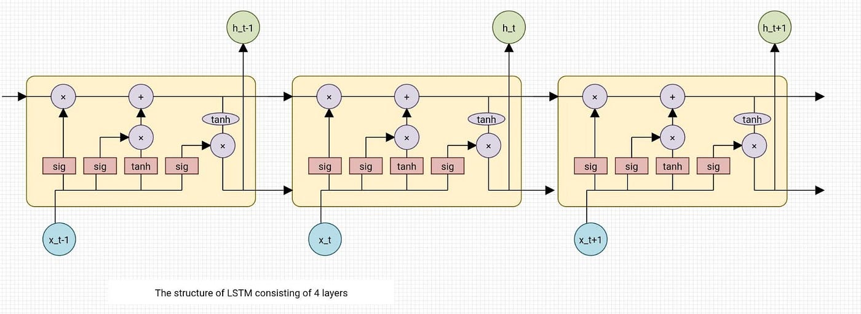

From the image on the top, you can see LSTMs have a chain-like structure. General RNNs have a single neural network layer. LSTMs, on the other hand, have four interacting layers communicating extraordinarily.

**LSTMs work in a three-step process.**

* The first step in LSTM is to decide which information to be omitted from the cell in that particular time step. It is decided with the help of a sigmoid function. It looks at the previous state (ht-1) and the current input xt and computes the function.
* There are two functions in the second layer. The first is the sigmoid function, and the second is the tanh function. The sigmoid function decides which values to let through (0 or 1). The tanh function gives the weightage to the values passed, deciding their level of importance from -1 to 1.
* The third step is to decide what will be the final output. First, you need to run a sigmoid layer which determines what parts of the cell state make it to the output. Then, you must put the cell state through the tanh function to push the values between -1 and 1 and multiply it by the output of the sigmoid gate.

With this basic understanding of LSTM, you can dive into the hands-on demonstration part of this tutorial regarding stock price prediction using machine learning.

* **MICROSOFT STOCK PRICE PREDICTION USING LSTM**

1.Import libraries:-

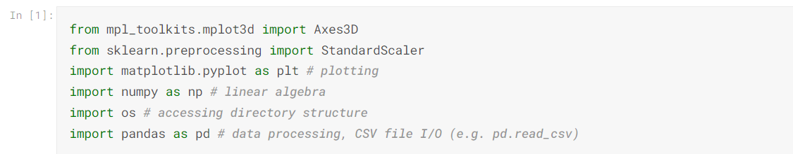

2.Csv File Of Dataset

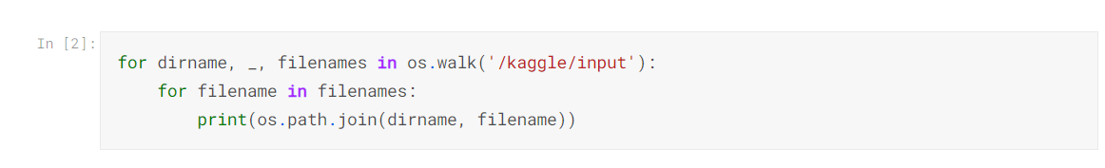

/kaggle/input/MSFT.csv

3. Plotting Dataset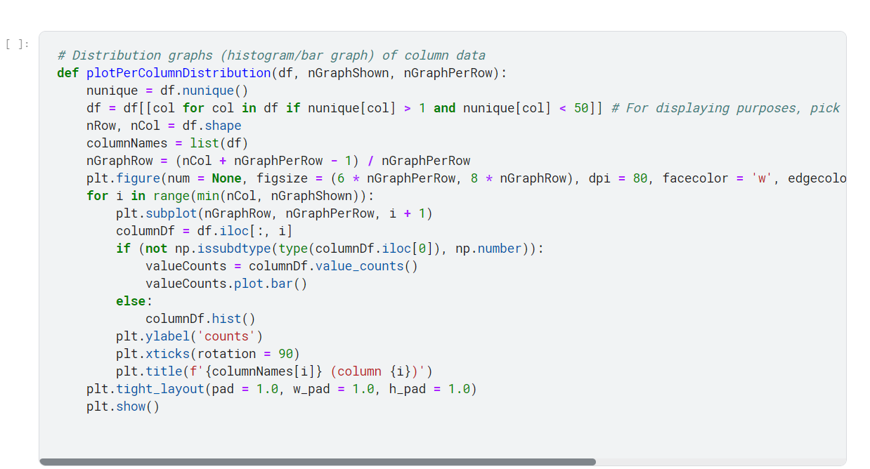

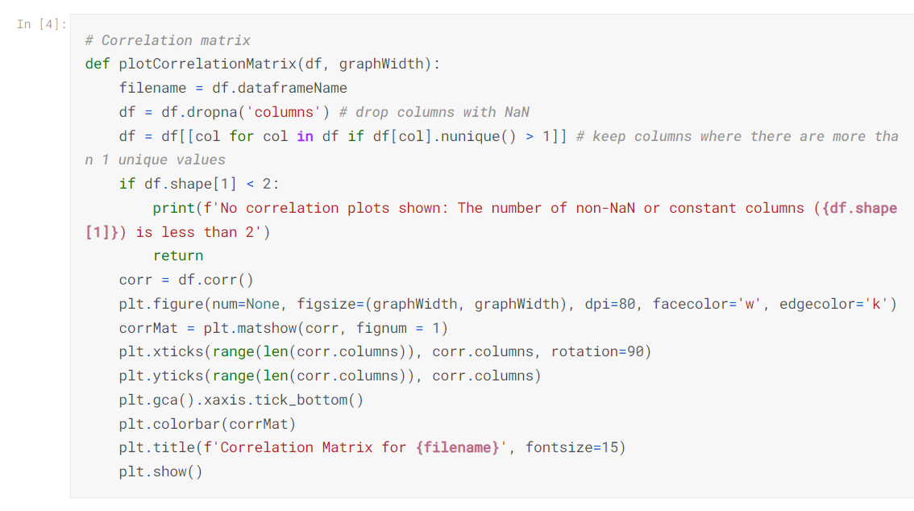

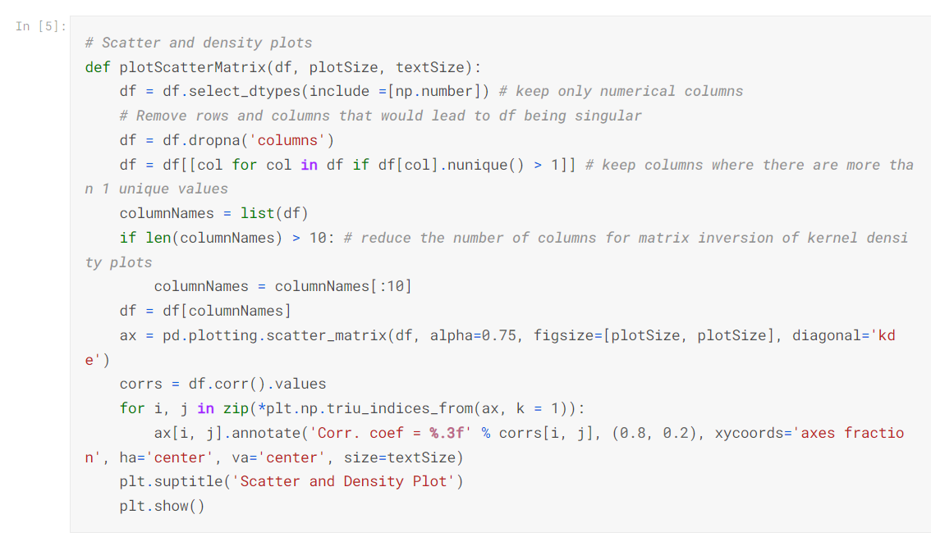

Now I’ts ready to read in the data and use the plotting functions to visualize the data.

### Let's check 1st file: /kaggle/input/MSFT.csv

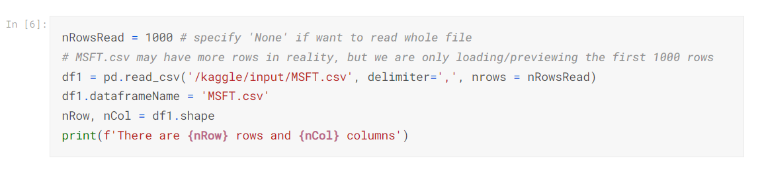

There are 1000 rows and 7 columns

Let's take a quick look at what the data looks like:

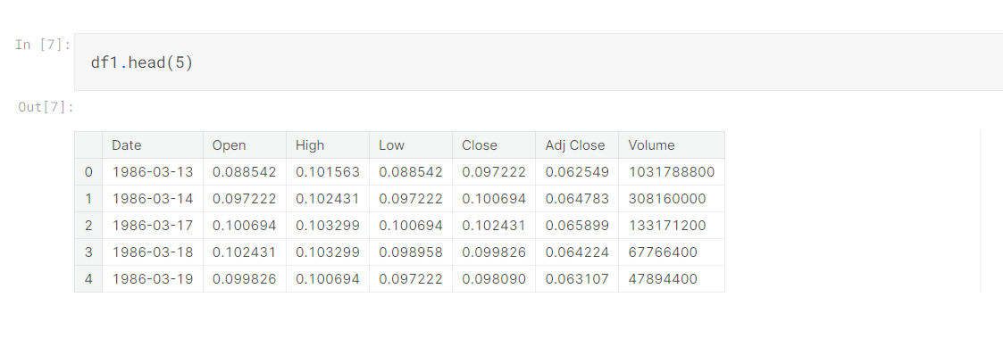Distribution graphs (histogram/bar graph) of sampled columns:

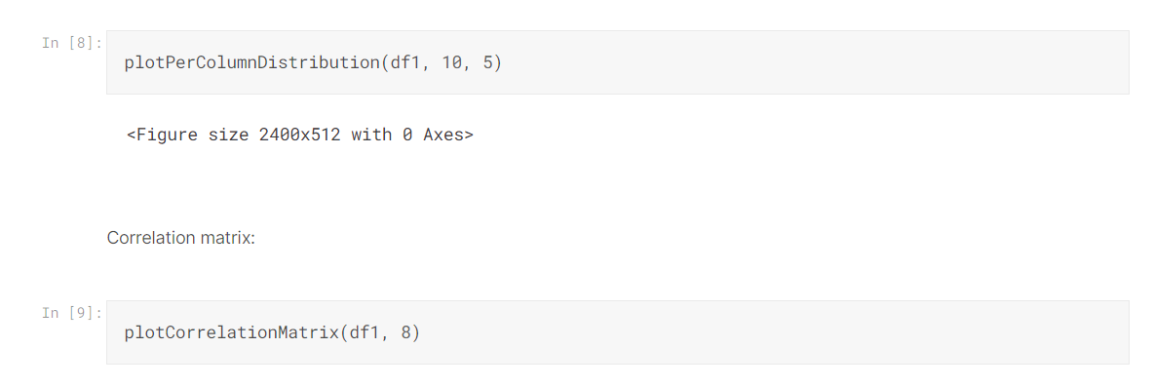

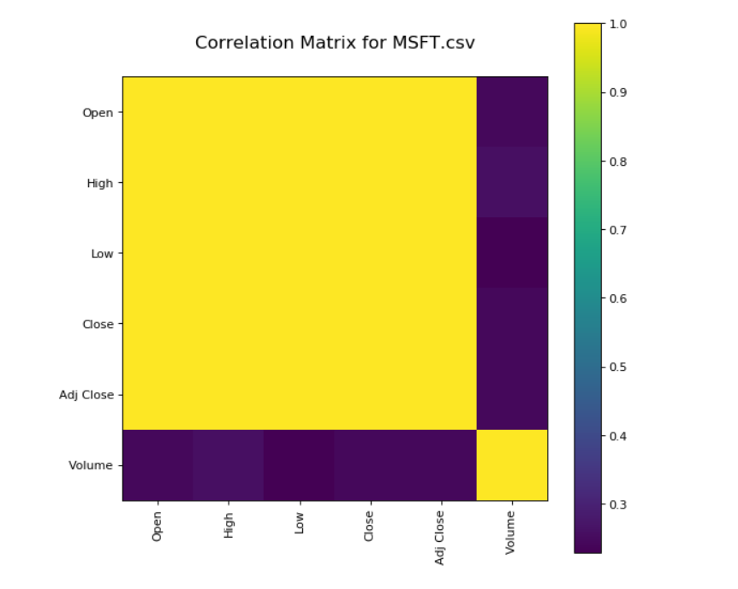

4.Scatter And Density Plot

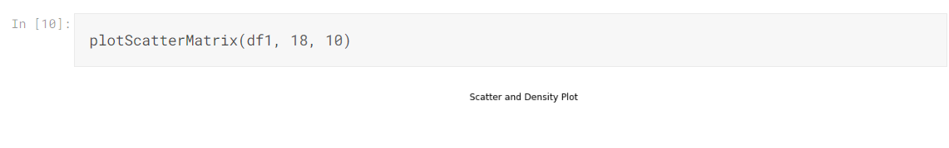

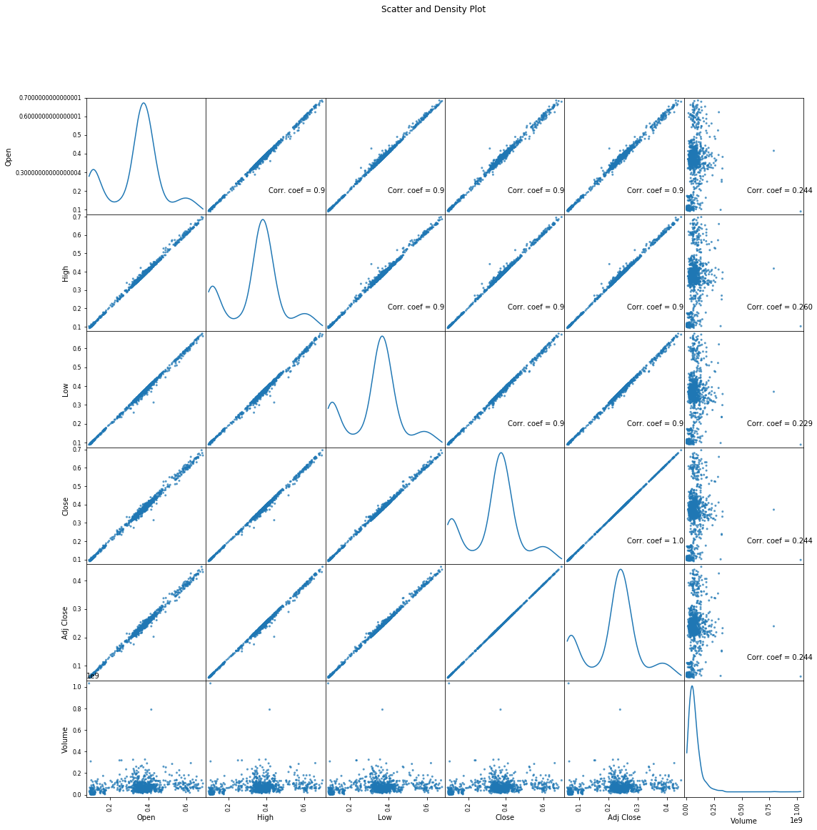

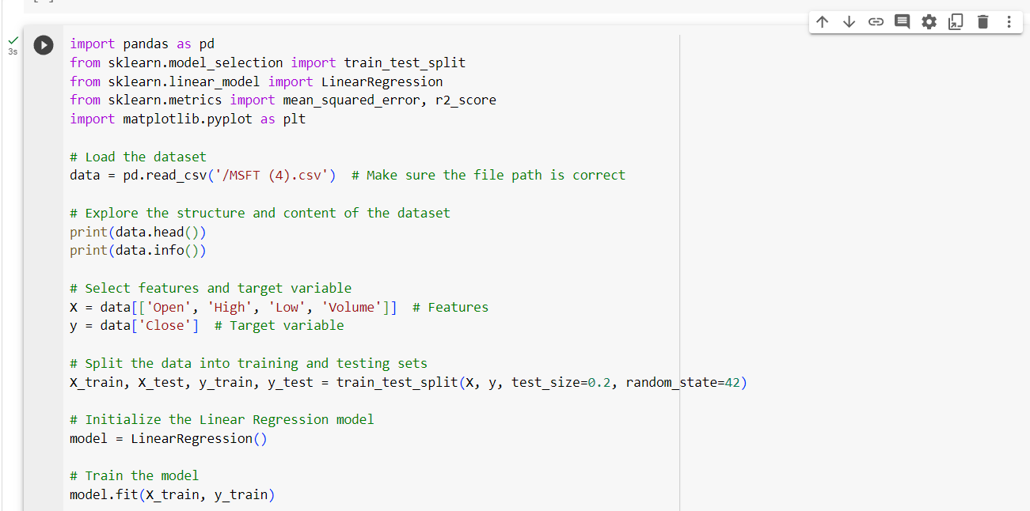

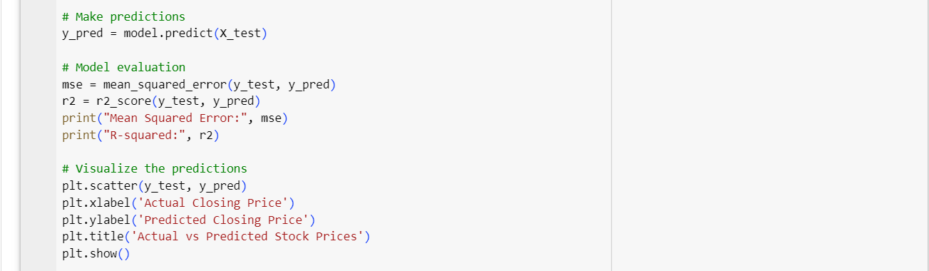

**OUTPUT:**

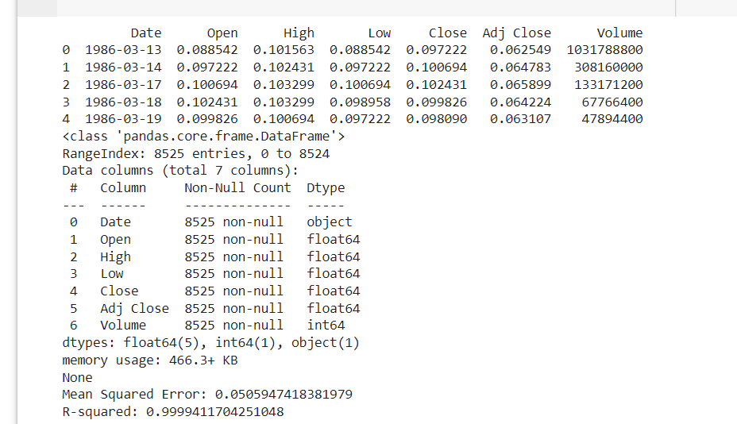

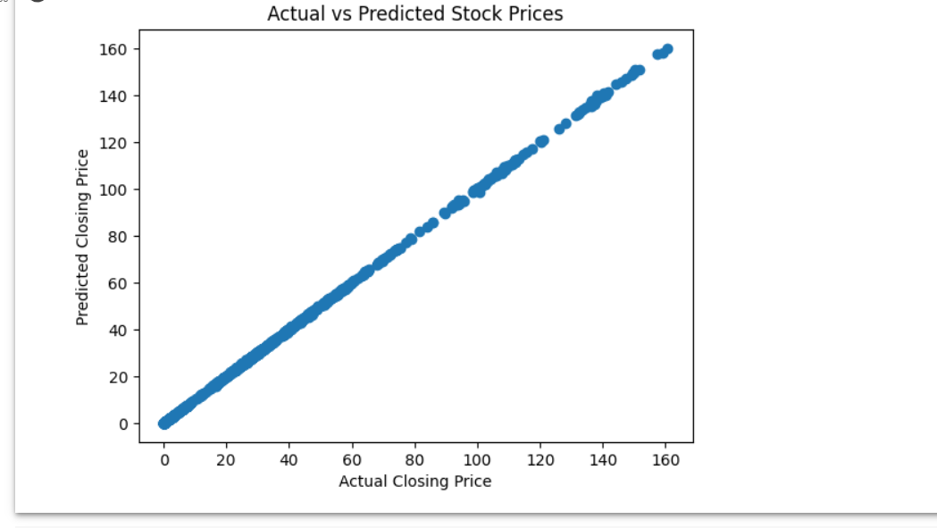

**SUBMITTED BY:**

**DEVIKA LAL G B**

**au720921244014**

**ANAGHA T J**

**au720921244006**

**SANDRA SURESH**

**au720921244046**

**PRABITHA N P**

**au720921244038**

**SRUDHINA M S**

**au720921244053**

**Third Year Computer science and Business System**

**Jct College Of engineering and technology**

**coimbatore**